Ex.No:1: Simulation of FDMA in MATLAB
Aim: To simulate a Frequency Division Multiple Access (FDMA) system using MATLAB and analyze its communication performance in terms of channel bandwidth, data rate, and signal-to-noise ratio (SNR).
Objective 1:
To simulate an FDMA system by allocating individual frequency channels to multiple users and determine the channel bandwidth assigned to each user.
Output Parameter: Channel Bandwidth (kHz)
Procedure :
- Open MATLAB and create a new script file.
- Define the total available bandwidth, number of FDMA users, carrier frequencies, signal power, and noise power.
- Allocate a unique frequency channel to each user and calculate the channel bandwidth.
- Compute the data rate for each user based on the allocated bandwidth and modulation scheme.
- Calculate the Signal-to-Noise Ratio (SNR) using the signal and noise power values.
- Plot the transmitted signals of all FDMA users using different carrier frequencies.
- Display the calculated channel bandwidth, data rate, and SNR in the MATLAB Command Window.
- Analyze the results to verify independent channel allocation and evaluate the overall performance of the FDMA system.

Program (Matlab Code)
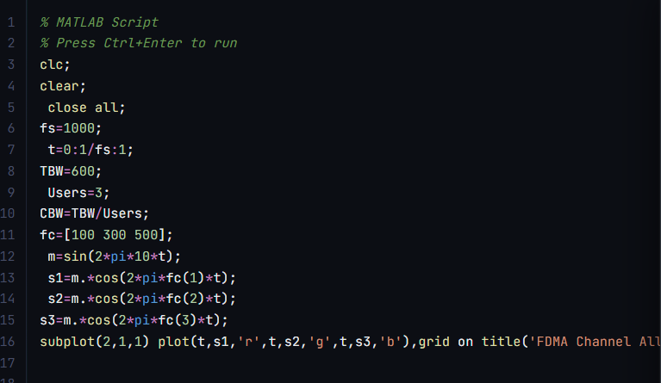

OUTPUT :
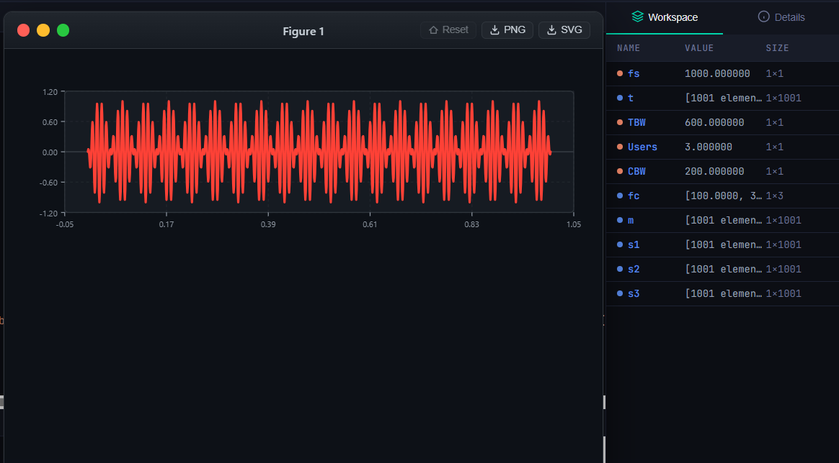

Result:
The FDMA system was successfully simulated by allocating separate frequency channels to three users, and the channel bandwidth assigned to each user was determined.
Objective 2:
To calculate the data rate achieved by each user in the FDMA system based on the allocated channel bandwidth.
Output Parameter: Data Rate (kbps)
PROGRAM :
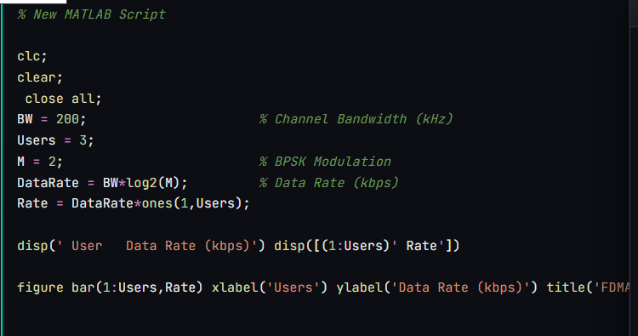

OUTPUT
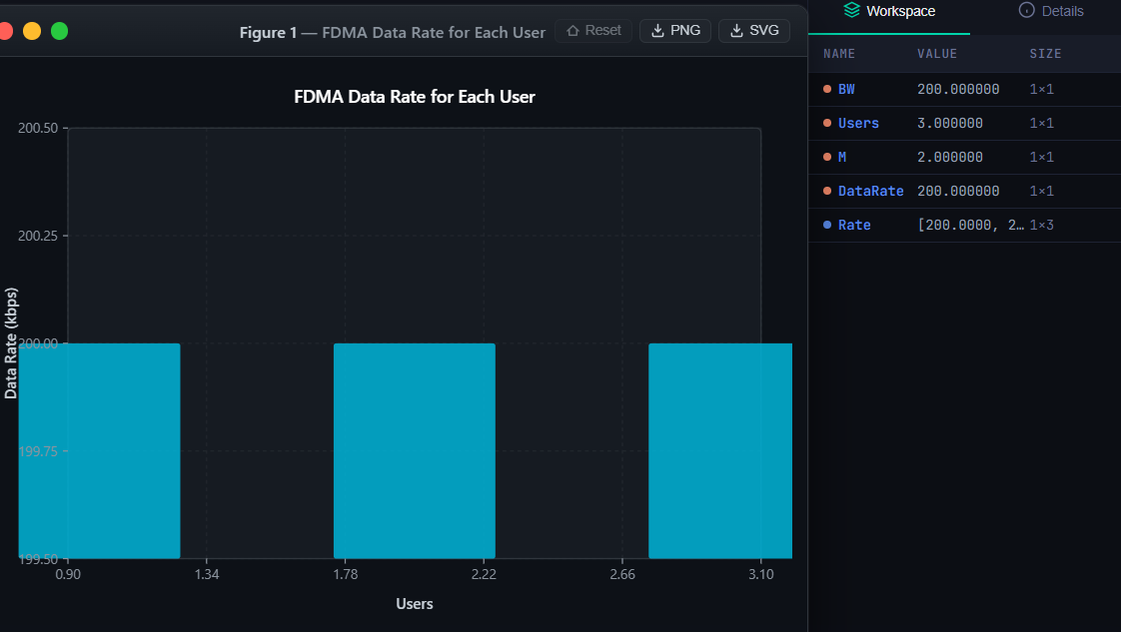

RESULT :
The data rate achieved by each user was successfully calculated based on the allocated channel bandwidth, demonstrating equal transmission capacity for all users.
Objective 3:
To evaluate the communication quality of the FDMA system by calculating the Signal-toNoise Ratio (SNR) for different users.
Output Parameter: Signal-to-Noise Ratio (SNR) (dB)

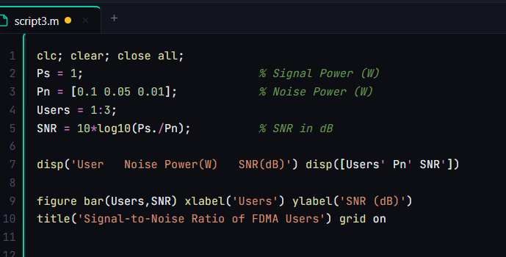
PROGRAM:

OUTPUT:
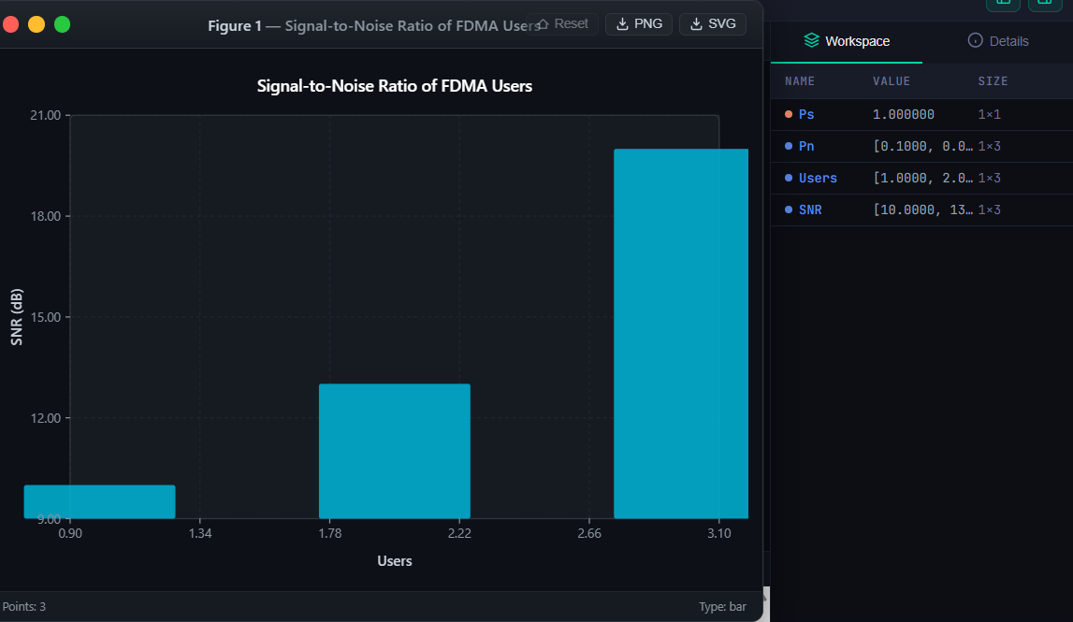

RESULT:
The Signal-to-Noise Ratio (SNR) for different users was successfully evaluated, showing that higher SNR values provide better communication quality and reliable data transmission.

